
Hednesford Valley High School

Post-16
Information
Book

“If you know you are on the right track, if you have this inner knowledge, then nobody can turn you off... no matter what they say.” – Barbara McClintock


Barbara McClintock won the Nobel Science Prize for her work with plant genetics in 1983, the first woman to do so unshared.

Key Dates

Autumn term:
EHCP’s / College Open Days (Dates in Pack)
6th Form Application Deadline 9th December 2024
Spring term:
6th Form Interviews: Week beginning 13th January 2025
Assessment Weeks: January 2025 (over 2 weeks)
Coursework will be due in by the end of April
Summer term:
Exams May & June 2025
Leaver’s Party – Thursday 26th June 2025
Friday 27th June – Last Day for leavers
Transition to 6th Form 30th June 2025

Life Post Year 11
Under government guidance, ‘Raising Participation Age’ (RPA), all young people up to the age of 18 must remain in some form of education or training.
Under government legislation a young person must re-sit English or Maths GCSE if they do not achieve a Grade 4 or above.

How to prepare for the examinations
KS4 Revision Club (3pm-4pm)
Parents / Carers should check the student’s planner regularly and discuss revision throughout the year.
Remember your child should be revising at home in preparation for their exams.
Good sources for this are BBC Bitesize and
SENECA learning websites.

Nova Training
Other School
NATSPEC

Work-Based Learning
HVH
Residential Colleges
6thForm

Your Child
Care Provision
Wolverhampton Vocational Training Centre

Walsall
Day Colleges
Lichfield

Tamworth

Cannock
Rodbaston
Stafford

Local College Open Days:

College Name | Open Day(s)
Walsall College | Thursday 10th October 2024 16:00PM-20:00PM
Cannock College | Saturday 12th October 2024 10:00AM-13:00PM
Lichfield College | Saturday 12th October 2024 10:00AM-13:00PM
Rodbaston College | Saturday 12th October 2024 10:00AM-13:00PM
Tamworth College | Saturday 12th October 2024 10:00AM-13:00PM
Wolverhampton Vocational Training Centre | Thursday 17th October 2024 14:30PM-17:45PM
Stafford College | Wednesday 23rd October 2024 17:30PM – 20:00PM

Post-16 Transport

- Unfortunately transport for post 16 students is not funded by the local education authority.
- There are schemes available for low-income families which will contribute some of the cost of transport, but you will need to contact the establishment you are wishing your child to attend as to what the process of applying for it is, if you are eligible.
- We can arrange travel training for your child, if appropriate, and the travel trainer will take your child to apply for a heavily discounted travel card.

What can we offer you?

- What can we offer you?
- Dedicated, well-trained staff
- Generous accommodation for learning
- English and Maths lessons led by specialists
- Work related learning and experience
- BTEC vocational courses
- If you are applying to our 6th Form, we offer a bursary of up to £400 per term.

Our 6th Form Curriculum Aims

The 6th Form curriculum is designed to provide students with the essential knowledge and skills necessary for achieving optimal life outcomes, building upon their previous accomplishments in school.
We are committed to continuously improving our 6th Form offerings by expanding the variety of accreditations and non-accredited activities available to our students.
Recognising that our sixth form students present a diverse range of needs and abilities, we have organised the department into distinct groups, each tailored with its own curriculum to maximize the life opportunities available to students.
Our curriculum is ambitious and adopts a highly personalised approach to learning, crafted specifically for each learner; we do not expect any student to conform to a predefined curriculum.

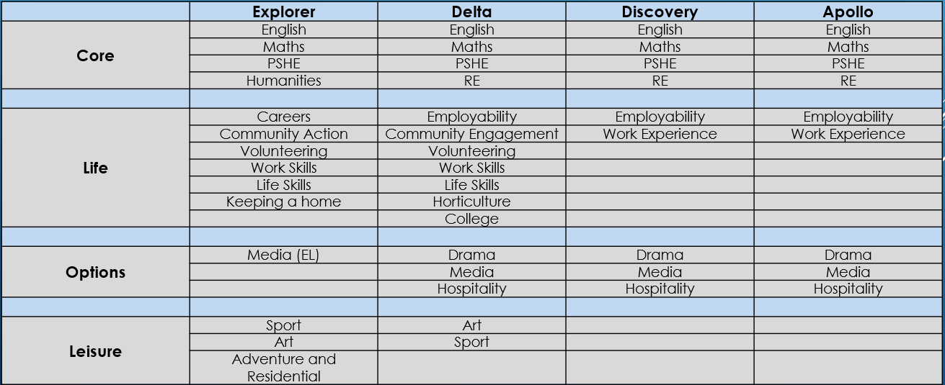
16 – 19 Curriculum

Interviews

- You will be called to an interview.
- You will be given a date and a time.
- Make sure you arrive early and take someone like a family member with you to support you.
- It is important you dress smartly for an interview so make sure you have your smartest clothes on for example your school uniform.
- Practice a few questions at home:
- What do you want to do in the future?
- What course do you want to study?
- Why do you want to do that course?

Any Questions?

Mrs Perry: e.perry@hvh.staffs.sch.uk

Mr Wall: c.wall@hvh.staffs.sch.uk

Mr Dale: a.dale@hvh.staffs.sch.uk

01543 423714

